Mechanical Task: تصميم مفصل القدم

Press (Ctrl + A) or Add => Mesh => Cylinder

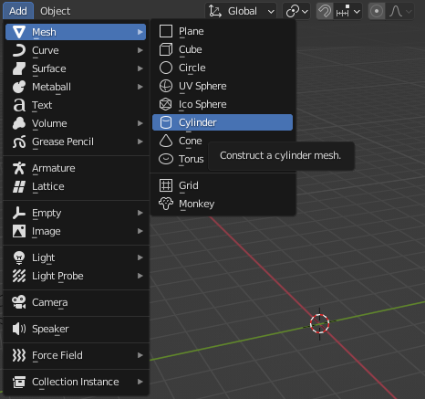

Change the (Depth and Rotation setting of the cylinder)

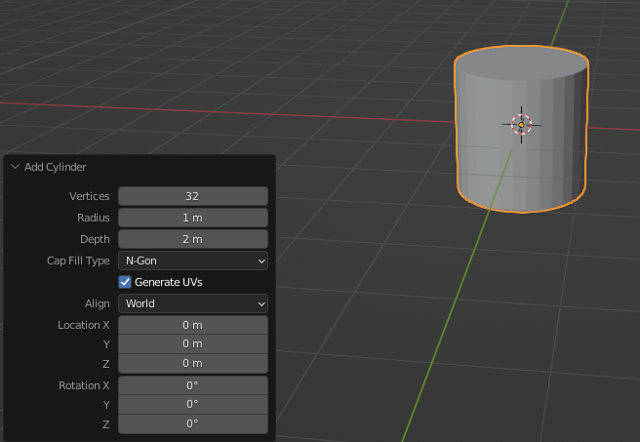

The new setting

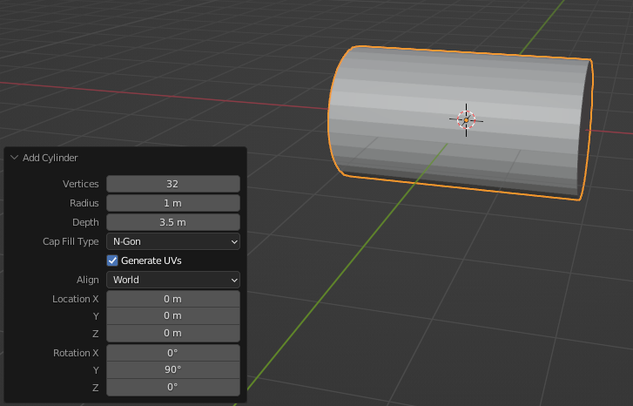

Copy this shape (Copy and paste) then click on the (Move tool) to move it

Then press on the red line to move this shape on the X-axis

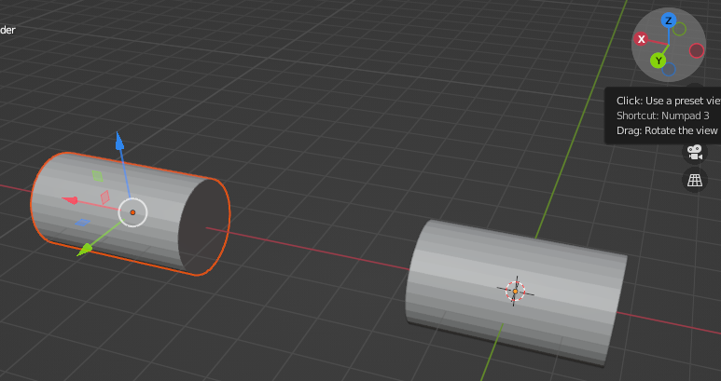

Make a cylinder in the middle between these two cylinders and change the depth and radius of it to fit in the center well.

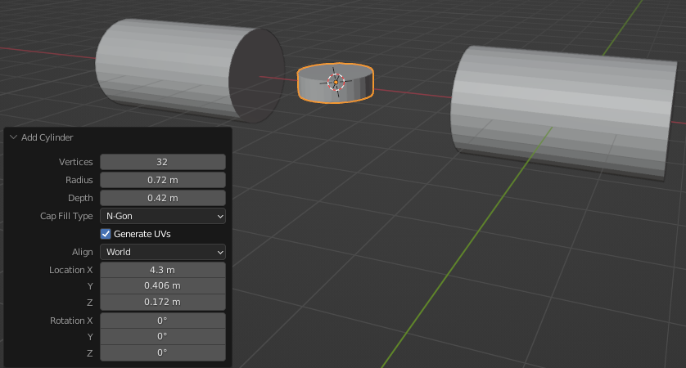

Then add another cylinder and change the Radius, Depth, and Rotation direction to make it on Y-axis

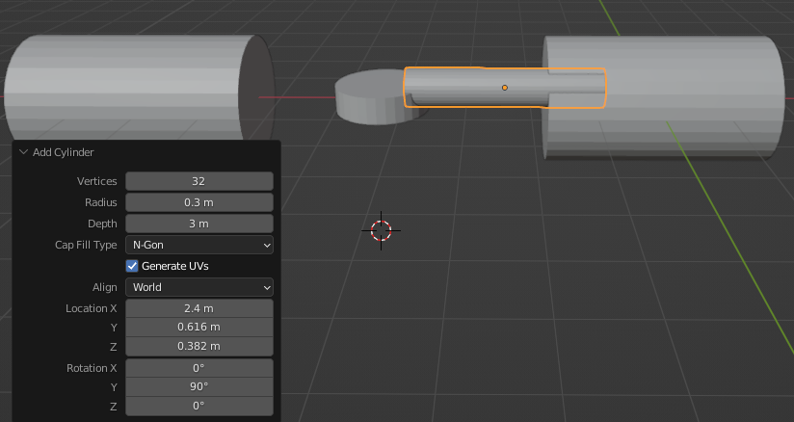

Connect the new cylinder with the two-by-move tool

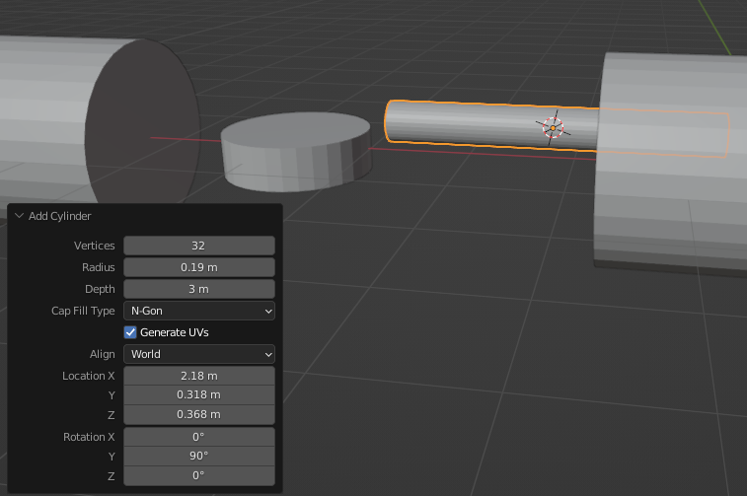

Connect Cylinder

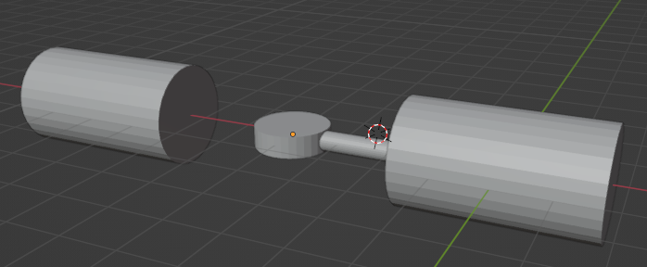

Make a hole in the middle cylinder to put the bearing inside it by clicking (Tab) on the middle cylinder

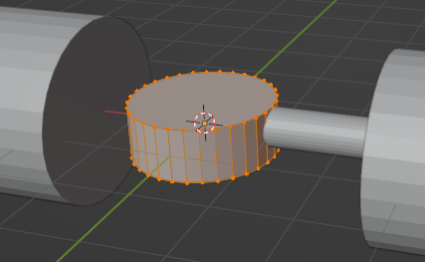

Then press (Alt + click) on the top of the cylinder

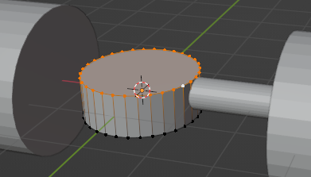

Then press (i)

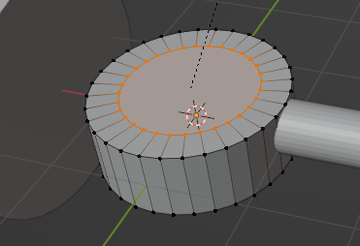

Press (Enter) then press (E) to make a depth

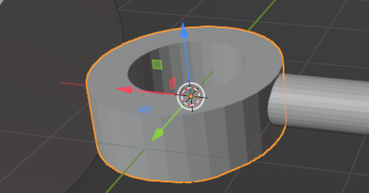

Then put the Bearing that you have in the center of this hole, but before you make this hole

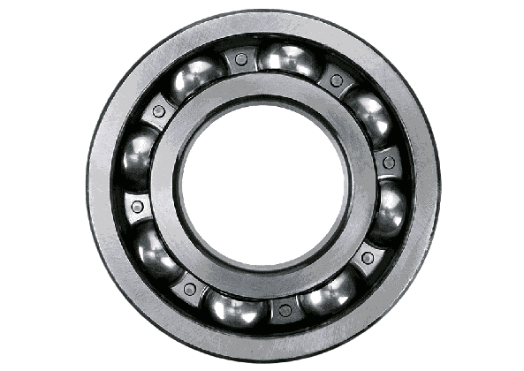

Note:

First: You must know the exact measurement of the bearing before you make the hole

Second: There is a way to change the size of anything by clicking on the object then Press (S)

An example of sizing

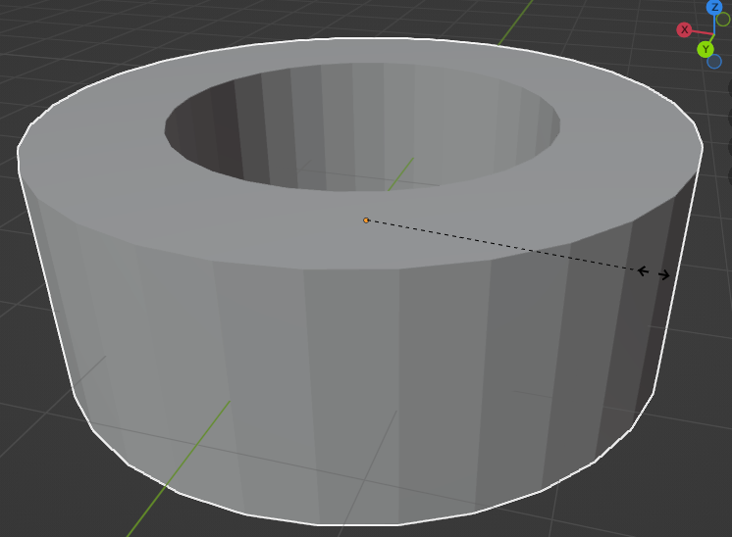

Note:

You can choose the place that you want to create by (Cursor Tool)

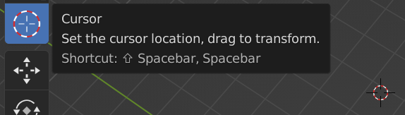

Make the Cursor in the middle center cylinder

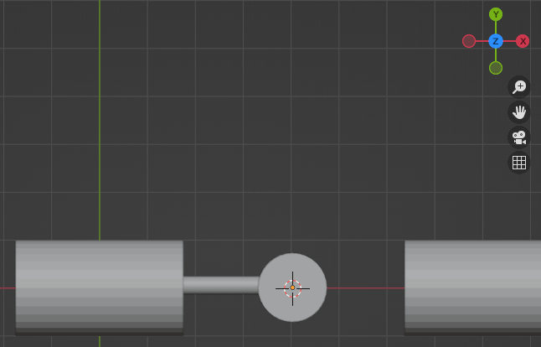

Make another cylinder in the middle but bigger and change the depth and radius and the rotation to make it in the Z-axis

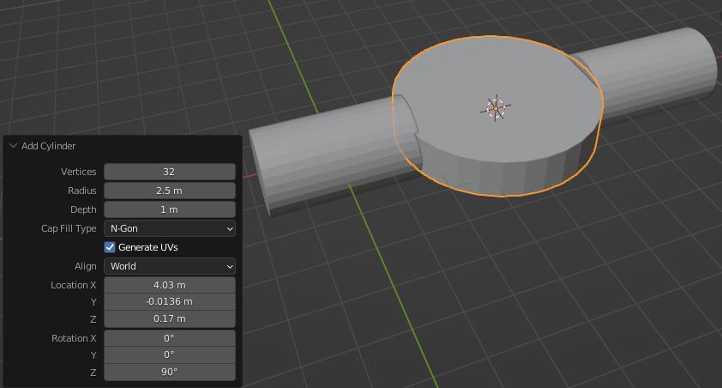

Choose the Move tool to move the cylinder far away at the edge of the middle cylinder

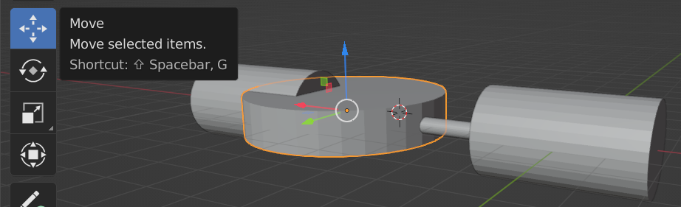

Press (Tab) on the last cylinder

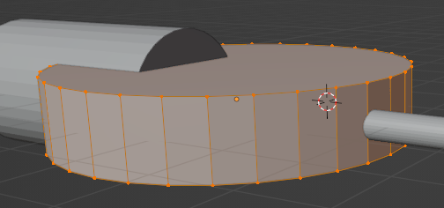

Then press on any space to get out of the selection then press (Alt + Shift) on the lines from the left middle lines to the right middle lines

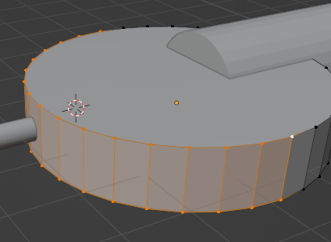

Then press ( i )

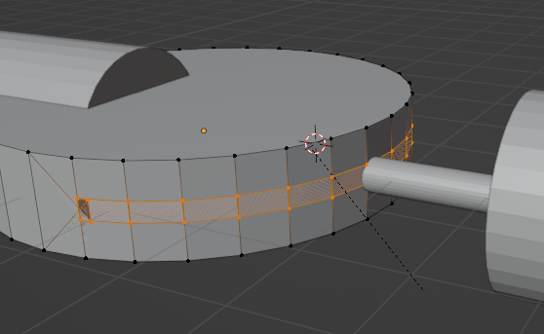

Then press (Enter)

After that press (E) AND move the selected shape away back

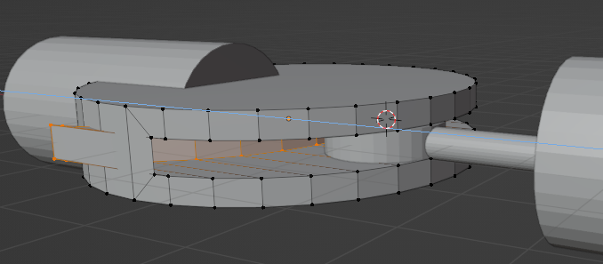

After that delete the extra shapes by pressing on every line of it and deleting every line

Note:

To delete press the right mouse then from the setting press



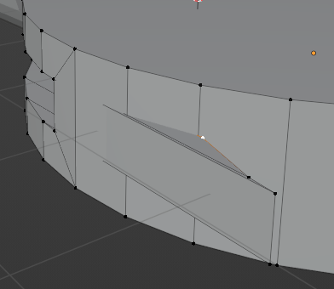

The new shape

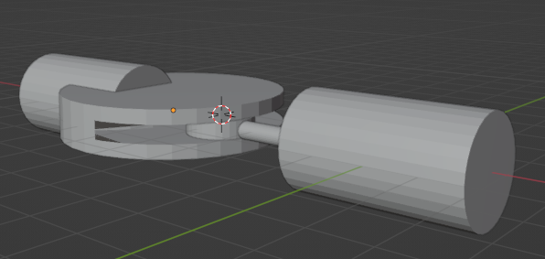

At the end make the final cylinder and put it in the middle to connect all cylinders together and make sure that it fits the center cylinder with the bearing

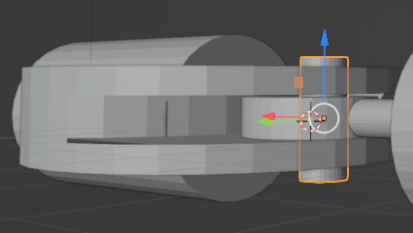

To change the color of the shapes press this icon

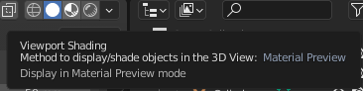

After that click on any shape then go to the right tools and press on Material Properties

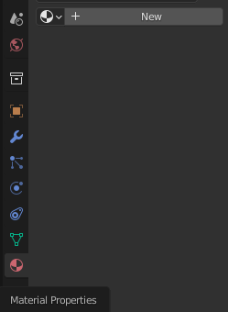

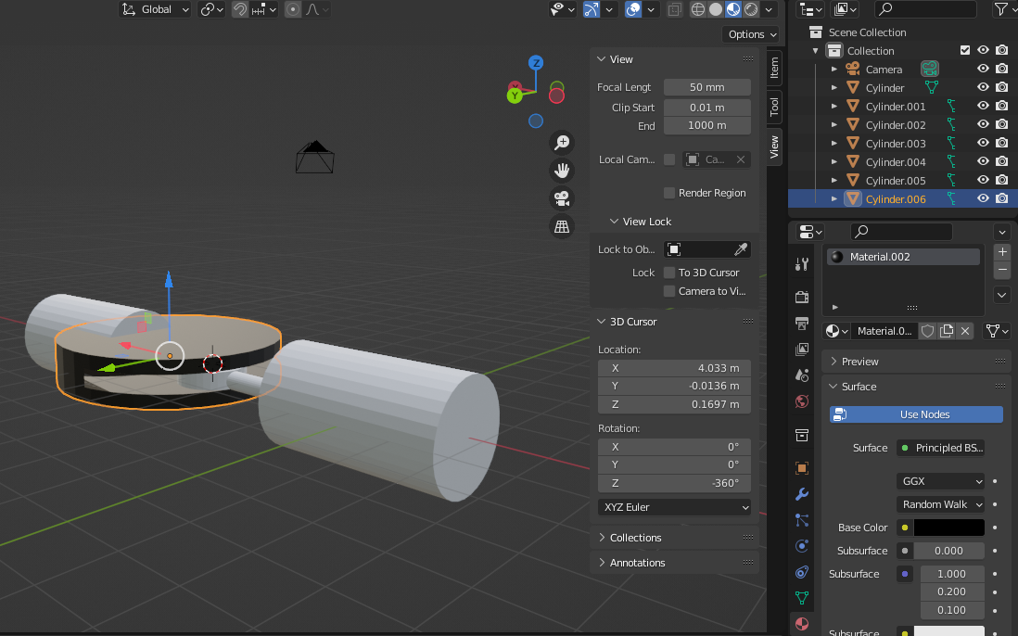

The end shapes

